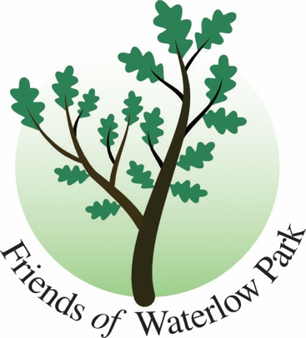

Friends of Waterlow Park Update

Highgate Breakfast Club to be held 5 October 2023.

LOOKING BACK –

The three Pop Up Proms held in the Park in August were much enjoyed and hopefully can be repeated next year. Thanks go to Lauderdale House for support and electrics. This year we featured Jazz, Irish and Latin combos.

LOOKING FORWARD --

THE FOWP Gardening Volunteers will be holding a sale of bulbs suitable for Autumn planting, on the Lauderdale House lawn this Sunday 7 October 11 till 3pm.

Biodiversity Surveying continues and sessions will run fortnightly on Saturdays from 14 October until 25 November. Meet us at 3pm at Pink Cafe (we are in Hi-Viz jackets) with Picture This app on your mobile and a clipboard if you have one. If you can spare an hour just one Saturday that would be an enormous help in this important and major project contributing to future sustainability in the park.

../2
Gardening Volunteers meet on Mondays and Thursdays. Apply via web form http://www.waterlowpark.org.uk/the-park/volunteering/

Camden is running a public consultation on whether to preserve some of the key views to the City from the Park. You can have your say via FOWP’s website https://www.waterlowpark.org.uk/london-skyline-proposal/ or Camden’s
https://consultations.wearecamden.org/supporting-communities/the-view-of-st-pauls-cathedral-from-waterlow-park/
Closes 30 November 2023.

Ends

chair@waterlowpark.org.uk

03 October 2023

